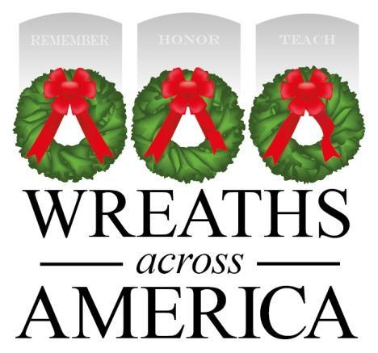
Wreaths Across America Story
Morrill Worcester of Harrington, Maine, was a 12-year-old paperboy when he won a trip to Washington D.C. His first trip to our nation’s capital was one he would never forget, and Arlington National Cemetery made an indelible impression on him. This experience followed him throughout his life and successful career as a wreath maker, reminding him that his good fortune was due, in large part, to the values of this nation and the veterans who made the ultimate sacrifice for their country.
In 1992, Mr. Worcester found himself with a surplus of wreaths nearing the end of the holiday season. Remembering his boyhood experience at Arlington, Worcester realized he had an opportunity to honor our country’s veterans. With the aid of former Maine Senator Olympia Snowe, arrangements were made for the wreaths to be placed at Arlington in one of the older sections of the cemetery that had been receiving fewer visitors with each passing year.
As plans were underway, several other individuals and organizations stepped up to help. Blue Bird Ranch, Inc., generously provided transportation all the way to Virginia. Volunteers from the local American Legion and VFW Posts gathered with members of the community to decorate each wreath with traditional red, hand-tied bows. Members of the Maine State Society of Washington, D.C. helped to organize the wreath laying, which included a special ceremony at the Tomb of the Unknown Soldier.
The annual tribute went on quietly for several years, until 2005, when a photo of the stones at Arlington, adorned with wreaths and covered in snow, circulated around the web. Suddenly, the project received national attention. Thousands of requests poured in from people wanting to help with Arlington, to emulate the Arlington project at their National and State cemeteries, or to simply share their stories and thank Worcester for honoring our nation’s heroes.
Unable to donate thousands of wreaths to each state, Worcester began sending seven wreaths to every state, one for each branch of the military, and for POW/MIAs. In 2006, with the help of the Civil Air Patrol and other civic organizations, simultaneous wreath-laying ceremonies were held at over 150 locations around the country.
In 2007, the Worcester family, along with veterans, and other groups and individuals who had helped with their annual veterans wreath ceremony in Arlington, formed Wreaths Across America, a non-profit 501c(3) organization, to continue and expand this effort, and support other groups around the country who wanted to do the same. The mission of the group is simple:

REMEMBER. HONOR. TEACH.
Fast-forward to 2022, Wreaths Across America and its national network of volunteers placed 2.7 million veterans’ wreaths at 3,702 participating locations in the United States and beyond last December. This was accomplished with help from some two million volunteers across the country, a third of which were children.
This year, National Wreaths Across America Day will be held on Saturday, Dec. 16, 2023.
Wreaths Across America would not be successful without the help of volunteers, active organizations, and the generosity of the trucking industry, which offer invaluable support to WAA's mission to remember the men and women who served our country, honor our military and their families, and teach our children about our freedom and those who protect it.
There are many ways you can help—visit www.wreathsacrossamerica.org to learn more and get involved!

