FOR IMMEDIATE RELEASE
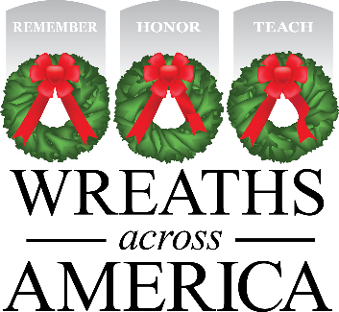

Local Effort Underway to Support Wreaths Across America
Volunteers to host fundraising events to ensure that all veterans at [PARTICIPATING LOCATION] are honored this December

Columbia Falls, MAINE, and [City, STATE] — [DATE], 2022 — Local volunteers are working hard to ensure that all veterans laid to rest at [local cemetery] are honored this December on National Wreaths Across America Day. This year, the ceremony, held simultaneously across the country at more than 3,100 participating locations, will be on Saturday, Dec. 17, 2022.

The goal: to place a live, balsam fir veteran’s wreath at the headstone of every servicemember buried there and ensure no one if forgotten.

Locally, volunteers will host various fundraisers to sponsor the [# of headstones] wreaths needed to honor every veteran at [cemetery]. [Each wreath sponsorship costs $15, with $5 going to the local sponsorship group for (nonprofit organization)] OR [For every two-wreath sponsorships sold, a third wreaths will be provided to [cemetery] as part of a special sponsorship group program option available through the national program.

[Bullet list of upcoming fundraising events: event, date and time.]

“Every donation and wreath sponsorship is a meaningful gift from a grateful American who knows what it means to serve and sacrifice for the freedoms we all enjoy,” said Karen Worcester, executive director of Wreaths Across America. “We are so grateful to the community of [town/city] for participating in our mission to Remember, Honor and Teach.”

[OPTIONAL: INSERT LOCAL FUNDRAISING STORY e.g., a local veterans’ group will be coordinating the fundraising event to raise money for both WAA and a new roof for its own facility.]

# # #

About Wreaths Across America
Wreaths Across America is a 501(c)(3) nonprofit organization founded to continue and expand the annual wreath-laying ceremony at Arlington National Cemetery begun by Maine businessman Morrill Worcester in 1992. The organization’s mission – Remember, Honor, Teach – is carried out in part each year by coordinating wreath-laying ceremonies in December at Arlington, as well as at thousands of veterans’ cemeteries and other locations in all 50 states and beyond.

All Wreaths Across America Day events are open to all people. For more information, to donate or to sign up to volunteer, please visit www.WreathsAcrossAmerica.org/YOURID

Press Contacts:
Local Person
local persons email address@where you need it sent .com,org,net
(and) number

Sean Sullivan
ssullivan@wreathsacrossamerica.org
(207) 230-4599

MEDIA RESOURCES

WAA Media Resource Page
https://learn.wreathsacrossamerica.org/mediaresources

