FOR IMMEDIATE RELEASE

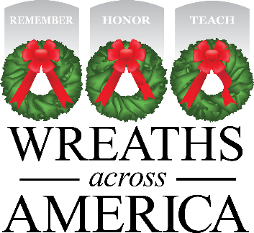

Local Wreaths Across America Event Planned for [time, date at location]
Volunteers help to Remember, Honor, Teach about our community’s heroes.

[YOUR TOWN, STATE] — [Date], 2022 — Local Wreaths Across America volunteers are working hard to ensure that all veterans laid to rest [at LOCATION] are honored this December as part of National Wreaths Across America Day – Saturday, December 17, 2022. In preparation for this annual event, (local group) is holding a (event) at (location) at (time) to raise awareness and wreath sponsorships to honor every veteran at (local cemetery).

“Every $15 wreath sponsorship made is a meaningful gift from a grateful American who knows what it means to serve and sacrifice for the freedoms we all enjoy,” said Karen Worcester, executive director of Wreaths Across America. “We are so grateful to the good people of this wonderful community for participating in our mission to Remember, Honor and Teach.”

Last year, ceremonies were held across the country at more than 3,100 participating locations, placing 2.4 million wreaths for interred veterans. This year Wreaths Across America Day will be held on December 17, 2022

The goal: to place a live, balsam fir veteran’s wreath at the headstone of every American veteran to Remember their sacrifice, Honor their service, and Teach the next generation about the value of freedom. For more information, to donate or to sign up to volunteer, please visit www.WreathsAcrossAmerica.org/YOURID

# # #

About Wreaths Across America
Wreaths Across America is a 501(c)(3) nonprofit organization founded to continue and expand the annual wreath-laying ceremony at Arlington National Cemetery begun by Maine businessman Morrill Worcester in 1992. The organization’s mission – Remember, Honor, Teach – is carried out in part each year by coordinating wreath-laying ceremonies in December at Arlington, as well as at thousands of veterans’ cemeteries and other locations in all 50 states and beyond.

All Wreaths Across America Day events are, non-political/religious events, open to all people. For more information, to donate or to sign up to volunteer, please visit www.WreathsAcrossAmerica.org/YOURID

Press Contacts:
Local Person
local persons email address@where you need it sent .com,org,net
(and) number

Sean Sullivan
ssullivan@wreathsacrossamerica.org
(207) 230-4599

MEDIA RESOURCES

WAA Media Resource Page
https://learn.wreathsacrossamerica.org/mediaresources

