FOR IMMEDIATE RELEASE
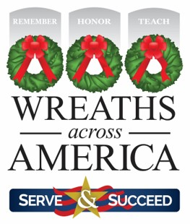

Wreaths Across America Announces New Flag Day Lesson Plans

TEACH Program provides free access to curriculum and educational resources specific to character and service-based learning.

COLUMBIA FALLS, Maine — June 5, 2023 — Today, Wreaths Across America (WAA) is proud to announce the addition of new Flag Day lesson plans to its TEACH Program which provides free access to curriculum and educational resources for all. Flag Day is celebrated June 14 and commemorates the adoption of the flag of the United States.

The new lesson plans, which have been designed for all grade levels and learning abilities have an objective for civic ideals and practices. “An understanding of civic ideals and practices is critical for full participation in society and is an essential component of education for citizenship,” said Cindy Tatum, WAA Curriculum Developer and Gold Star Mom. “This theme enables students to learn about the rights and responsibilities of citizens of a democracy, and to appreciate the importance of active citizenship.”

The WAA TEACH Program helps serve professional and amateur educators by acting as a conduit to share established curriculum materials from like-minded partner organizations. Additionally, WAA develops original curriculums (like the new Flag Day materials) to help educators in their endeavor to provide quality learning experiences for their students.

To learn more or download lesson plans from WAA’s TEACH Program, please visit www.wreathsacrossamerica.org/teach.

This year, National Wreaths Across America Day is Saturday, December 16, 2023. It is a free event and open to all people. For more information on how to volunteer locally or sponsor a wreath for an American hero, please visit www.wreathsacrossamerica.org.

# # #

About Wreaths Across America
Wreaths Across America is a 501(c)(3) nonprofit organization founded to continue and expand the annual wreath-laying ceremony at Arlington National Cemetery begun by Maine businessman Morrill Worcester in 1992. The organization’s mission – Remember, Honor, Teach – is carried out in part each year by coordinating wreath-laying ceremonies in December at Arlington, as well as at thousands of veterans’ cemeteries and other locations in all 50 states and beyond.

Press contact:
Sean Sullivan
(207) 230-4599
ssullivan@wreathsacrossamerica.org

Media Resources

