Thank you for coming today to help us lay wreaths in honor of our Veterans!

You will find veterans’ wreaths {{Insert specific information about where they will pick up a wreath or
where to place if assigned}}. Please take a moment to SAY THEIR NAME ALOUD
as you lay each wreath to keep their memory alive.

Proper Wreath Placement on Graves
Upright headstones - Place wreath propped against an upright headstone with the top of the wreath (bow) centered on the headstone.
Flat headstones - Place wreath flat on ground with the top of the wreath (bow) centered at the base of the headstone.

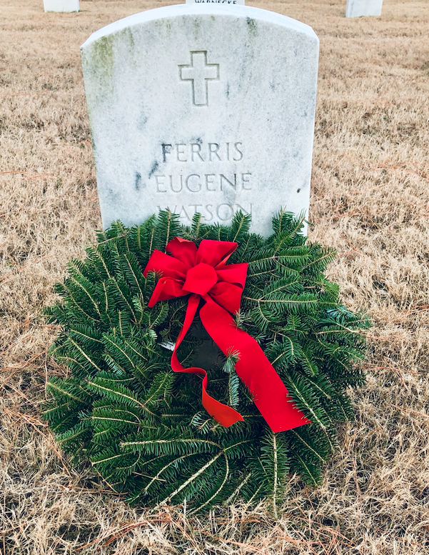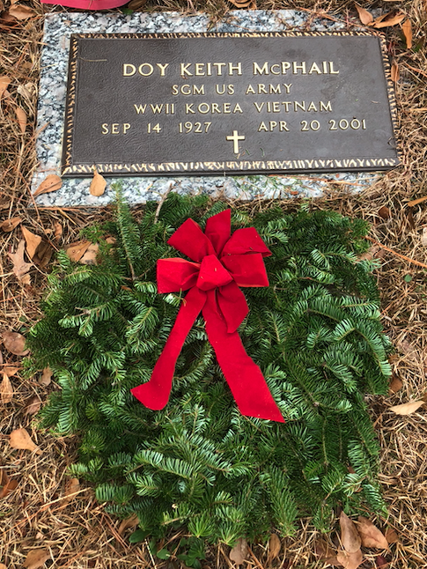

In accordance with and out of respect for Jewish custom, we ask that you do not place wreaths on the headstones of servicemembers with a Star of David. Please take a moment to stop and say their name, but do not place a wreath. (Important: If you come to a headstone with a Star of David and a wreath is already placed there, please leave it as this may have been placed directly by family or friends.)
Star of David
emblem of belief

Parents, guardians, and chaperones – Please communicate these instructions to your children participating today, to ensure they understand which gravesites should or should not receive a wreath.

Wreath Laying Procedure
- Receive the wreath and approach the headstone.
- Extend the wreath outward, offering it to the veteran.
- Place the wreath centered at the headstone, with the bow at the top.
- Say the veteran's name aloud.
- Please do not remove any items already placed at headstones, such as other wreaths, flowers, and other tokens left by family or friends.
- For military and cadets - render a slow salute or place a right hand over your heart.

Feel free to take a tag from the back of any wreath as a memento of your efforts today. With over {{Insert number of veteran graves}} laid to rest at {{insert cemetery name}} we couldn’t do this without you!

THANK YOU for helping us REMEMBER, HONOR, and TEACH on National Wreaths Across America Day!

To all WAA Volunteers:

Thank you for being here today…

Before you get started, there are some items to be brought to your attention, to make your experience even better.

1) Each wreath you’ll be placing is handmade and unique. They are made of balsam fir grown in the Downeast region of Maine, USA, with pride.

2) Some of the needles do become detached during the making, packing, and transportation of the wreaths. Please keep in mind that every wreath has tens of thousands of needles and it is normal for this to happen.

3) Because the wreaths are packed tightly in boxes, it will take 2-3 hours for them to fully relax to their natural circular shape.

4) Before placing a wreath on a headstone, take a minute to re-fluff the greens and rearrange the bow. When the wreath is finally laid at the headstone, please make sure the bow is at the 12:00 position.

It is important to have that intimate moment with the hero you are honoring, but please remember to take a step back and look at the complete picture of what all of us have accomplished through the mission to REMEMBER, HONOR, and TEACH.

Again, thank you for your patriotism. Without you, National Wreaths Across America Day would not be so nice.

God Bless our Veterans and God Bless America.

With thanks,

Morrill Worcester

Founder, Wreaths Across America

