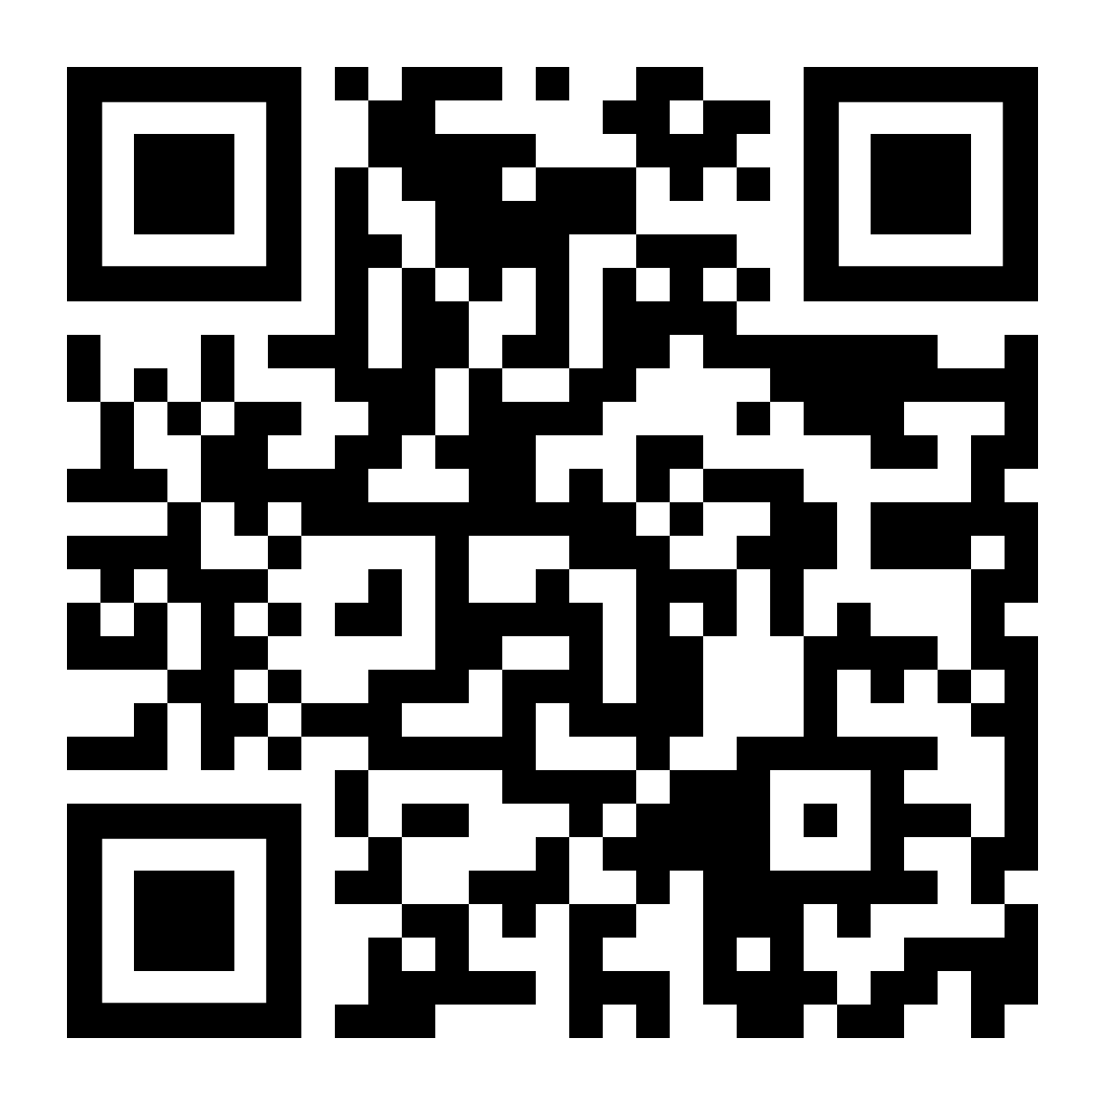
Wreath Sponsorship Form

Sponsored wreaths are placed on grave markers at state and national veterans’ cemeteries, as well as at local, community cemeteries each December. For quicker processing and the convenience of paying with a credit card, debit card, Google Pay, or PayPal, wreaths may be sponsored as grave specific requests online by scanning the QR Code above or visiting {{insert direct link to group page and update the QR code}}. If you prefer to pay with a check, please complete this form and mail it along with your check to the address in the box on the right. Thank you for your support!
Please make checks payable to:
Wreaths Across America
PO Box 249
Columbia Falls, ME 04623

Call 877-385-9504 with any questions.
Thank you for your sponsorship and joining us in our mission to Remember, Honor and Teach!

Name: ______________________________________________________
Address: ____________________________________________________
City: ________________________________________________________
State: ___________________________ Zip: ________________________
Phone: ______________________________________________________
Email: ______________________________________________________

Sponsorship Type | Price | Quantity | Total
Individual = 1 Wreath | $15.00
Mailed "In Honor" card = If you wish to send a physical honor card telling someone of your sponsorship, please see "In Honor" section below. The $2 fee is required for this mailing. | $2.00
Family = 4 Wreaths | $60.00
Small Business = 10 Wreaths | $150.00
Corporate = 100 Wreaths | $1,500.00
 |  | Grand Total

*GRAVE SPECIFIC REQUESTS ARE NOT ACCEPTED ON THIS FORM*

In Memory of:

This name will be listed on our online memory wall. Below, please provide name, rank, branch of service and state resided.

Branch of Service: _______________________________
Rank: __________________________________________
State: __________________________________________

In Honor of: _________________________________
Below, please provide email or mailing address of “In Honor of” recipient so we can notify them of your sponsorship in their honor. If you have a specific message, please write it on the back of this sheet.
Email address: _______________________________
Mailing address: ______________________________
_____________________________________________

Please note, ALL sponsored wreaths are shipped directly to the location and NO wreaths are sent to the individuals purchasing sponsorships.
Location ID: ____________________ Sponsorship Group ID: ______________________
---------------------------------------------------------------------------------------------------------------------------------------------
FOR OFFICE USE ONLY:

Cash: ________________________ Total: ______________________ Date Received: _______________________

Total No. Checks: _________________ Reconciled: ____________________

MO: ________________________

Entered: ______________________

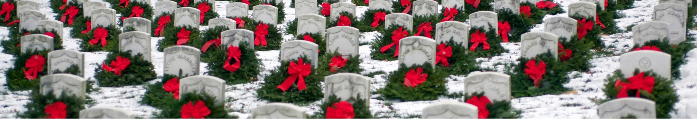
GEN:

