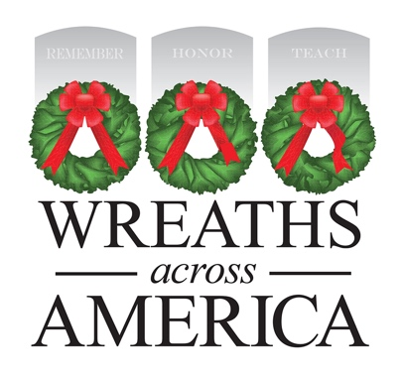
Media Advisory Template
MEDIA ADVISORY
PHOTO/VIDEO OPPORTUNITY
National Wreaths Across America Day to be Held at [Cemetery Location]
WHAT: [Cemetery name], an official Wreaths Across America (WAA) location, will host a wreath-laying ceremony, joining more than 3,700 other locations across the country for National Wreaths Across America Day. Coordinated and led by local volunteers, sponsorship groups have raised funds throughout the year to sponsor the placement of [#] veterans’ wreaths on the headstones of our fallen service members laid to rest there. This annual event seeks to further the yearling mission to Remember, Honor, Teach, ensuring that the memory of those who served our country endures.
WHEN: Saturday, December 16, 2023
Please specify times for wreath placement and ceremony if hosting both events.

WHERE:
[Cemetery name and specific location of ceremony]
[Address]

WHO:
[Military dignitaries/officers]
[Local dignitaries (e.g., state representative, governor, city councilors)]
Veterans, active service members and families

About Wreaths Across America
Wreaths Across America is a 501(c)(3) nonprofit organization founded to continue and expand the annual wreath-laying ceremony at Arlington National Cemetery begun by Maine businessman Morrill Worcester in 1992. The organization’s yearlong mission – Remember, Honor, Teach – is carried out in part each year by coordinating wreath-laying ceremonies in December at Arlington, as well as at more than 3,700 veterans’ cemeteries and other locations in all 50 states and overseas.

Volunteer Location Contact:
[Coordinator name]
[Cell phone]
[Email address]

