FOR INTERNAL REVIEW ONLY
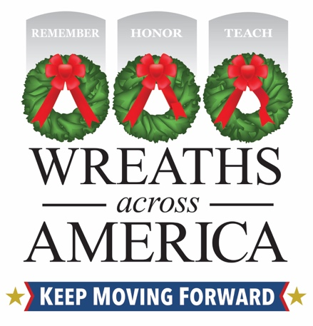
Join Wreaths Across America’s Annual Giving in July Celebration
Support [Name of Your Sponsorship Group] in your community, which is raising funds and sharing the mission to Remember, Honor and Teach.
COLUMBIA FALLS, Maine and (YOUR CITY, State) – DATE, 2025 – [Name of local group] is pleased to announce that it is participating in the national nonprofit Wreaths Across America’s (WAA) annual Giving in July campaign! For WAA, this annual celebration is dedicated to those local groups and individuals participating in the organization’s Sponsorship Group Program. Through this unique program, supporters can help local programs – nonprofits, civic groups and other like-minded organizations – make a difference in their communities through each $17 sponsorship made to WAA.
Locally, [name of your sponsorship group] counts itself as one of those sponsorship groups that support the mission to Remember, Honor, and Teach while raising funds to [insert some details about how your group uses your $5 back].
Please visit www.wreathsacrossamerica.org/YOURID) and sponsor a veteran’s wreath today, and [name of group] will receive $5 back for your $17 sponsorship!
Since its founding in 2007, WAA has collaborated with hundreds of like-minded charities, community programs, and civic groups nationwide to remember and honor our nation’s veterans and active-duty military all year long. Giving in July celebrates these groups and highlights the opportunity to give back to them by sponsoring veterans’ wreaths through the organization’s Group Sponsorship Program.
Over the last 17 years, WAA has given back more than $28 million in local contributions through this national program!
“I have long said it would be disingenuous for us as an organization whose mission is to Remember the fallen, Honor those that serve, and Teach the next generation the value of freedom if we do not support other like-minded programs doing just that in their communities,” said WAA Executive Director Karen Worcester. “Our Group Sponsorship Program is a year-round effort, but through “Giving in July,” we hope to remind people that veterans and our current military serve and protect us 365 days a year, and it is never too early to make a difference in your own community.”
More than 5,000 locations will participate in National Wreaths Across America Day this year on Saturday, December 13, 2025 – including at locally at [name of location(s) your group supports]. This free event is open to all, and the organization encourages community members to participate by volunteering locally or sponsoring a wreath for an American hero.
Follow the hashtag #GivinginJuly to learn the impactful stories of volunteers and Sponsorship Groups doing good in their communities and benefitting from dollars raised through wreath sponsorships. Tune in to Wreaths Across America Radio to hear their stories, available on the iHeart Radio app, TuneIn, and the Audacy app, or at www.wreathsacrossamerica.org/radio.
About Wreaths Across America
Wreaths Across America is a 501(c)(3) nonprofit organization founded to continue and expand the annual wreath-laying ceremony at Arlington National Cemetery, which was begun by Maine businessman Morrill Worcester in 1992. The organization’s yearlong mission – Remember, Honor, Teach – is carried out in part each year by coordinating wreath-laying ceremonies in December at Arlington and at thousands of veterans’ cemeteries and other locations in all 50 states and beyond.
For more information or to sponsor a wreath, please visit www.wreathsacrossamerica.org.
WAA Press Contacts:
Rachael Wilson
rwilson@wreathsacrossamerica.org
(207) 230-4599

[LOCAL VOLUNTEER CONTACT INFO]
NOTES TO MEDIA AND PRESS MATERIALS: Please visit our Media Resources Page to download background, photos, logos, or other items to help you file your story.
Please get in touch with the local WAA Volunteer listed for interviews and more information about local efforts.

