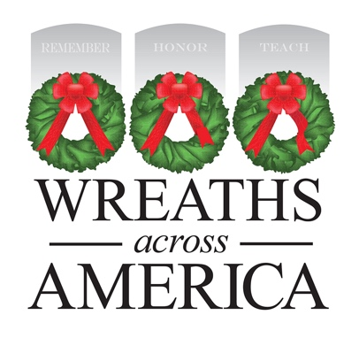
MEDIA ADVISORY
PHOTO/VIDEO OPPORTUNITY

Local Wreaths Across America Sponsorship Group to Host [EVENT]
WHAT: [Group name] is fundraising to support Wreaths Across America, specifically to earn sponsorships for veterans’ wreaths to be placed at [Location] on National Wreaths Across America Day – Sat., December 16, 2023.
[Add a line or two about the specific event — such as what’s involved and if the public can attend — and try to note any interesting visuals for broadcast media.]
WHEN: [Date + Time]
WHERE: [Address]
WHO: [List anyone attending who the media could interview or who might draw the media’s interest.]
About Wreaths Across America
Wreaths Across America is a 501(c)(3) nonprofit organization founded to continue and expand the annual wreath-laying ceremony at Arlington National Cemetery begun by Maine businessman Morrill Worcester in 1992. The organization’s mission – Remember, Honor, Teach – is carried out in part each year by coordinating wreath-laying ceremonies in December at Arlington, as well as at more than 3,700 veterans’ cemeteries and other locations in all 50 states and overseas.

Volunteer Location Contact:
[Coordinator name]
[Cell phone]
[Email address]
# # #

