FOR IMMEDIATE RELEASE

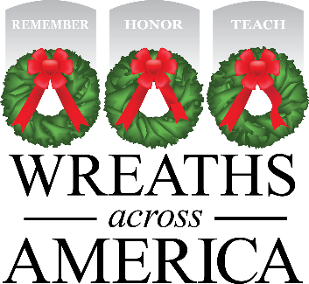

American Pride on Display at this Year’s

National Wreaths Across America Day Event

More than 2.7 million Sponsored Veterans’ Wreaths were Placed by Volunteers at 3,702 Participating Locations Across the Country including at [Location Name]

COLUMBIA FALLS, ME and [CITY, State Abr.] — Dec XX, 2022 — National Wreaths Across America Day took place today at 3,702 participating locations across the country. Our nation’s heroes were remembered as each name was said aloud and honored as over two million volunteers, a third of whom were children, helped placed more than 2.7 million veterans’ wreaths on headstones of our fallen across the country. At [Participating Location] specifically, [#] veterans’ wreaths were placed by more than [#] volunteers.

Wreaths Across America would like to thank the community, dedicated volunteers, generous sponsors, essential truck drivers, area officials, and members of the media for coming together in unity and supporting those who have protected our freedom. Each person has played an important part in the mission to Remember the fallen, Honor those that serve and their families, and Teach the next generation the value of freedom.

Each live, balsam veteran’s wreath was a gift of respect and appreciation, sponsored by an individual or organization and placed on a headstone by volunteers as a small gesture of gratitude for the freedoms Americans enjoy. For centuries, fresh evergreens have been used as a symbol of honor and have served as a living tribute renewed annually. Wreaths Across America believes the tradition represents a living memorial that honors veterans, active-duty military, and their families. When each wreath is placed the servicemember’s name is said out loud, ensuring their memory lives on.

For more information, visit www.wreathsacrossamerica.org/YOURID. Next year’s National Wreaths Across America Day will be held on Saturday, Dec. 16, 2023.

# # #

About Wreaths Across America
Wreaths Across America is a 501(c)(3) nonprofit organization founded to continue and expand the annual wreath-laying ceremony at Arlington National Cemetery begun by Maine businessman Morrill Worcester in 1992. The organization’s mission – Remember, Honor, Teach – is carried out in part each year by coordinating wreath-laying ceremonies in December at Arlington, as well as at thousands of veterans’ cemeteries and other locations in all 50 states and beyond.

For more information or to sponsor a wreath please visit www.wreathsacrossamerica.org.

Press contacts:

LOCAL CONTACT
EMAIL
PHONE
Sean Sullivan
ssullivan@wreathsacrossamerica.org
(207) 230-4599

WAA Media Resource Page and 2022 Media Guide
https://learn.wreathsacrossamerica.org/mediaresources

