FOR IMMEDIATE RELEASE
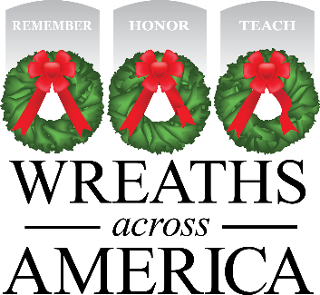

[CEMETERY] Announces it will (Become OR Continue as) an Official Location for the 2023 National
Wreaths Across America Day

The cemetery will join the more than 3,700 participating locations across the country to Remember, Honor and Teach on Saturday, Dec. 16, 2023
Columbia Falls, MAINE, and [City, STATE] — [Date], 2023 — National nonprofit Wreaths Across America (WAA) announced today that [LOCATION] in [City, State] has once again joined OR will be joining in the mission to Remember, Honor, Teach, as an official location for 2023. This is the [FIRST, SECOND, THIRD, etc.,] year that the cemetery will participate in this national program

Wreaths Across America started as a simple gesture of thanks that has grown into a national, yearlong movement of dedicated volunteers and communities coming together to not only remember the nation’s fallen and honor their service, but to teach the next generation about the value of freedom. This year, there will be more than 3,700 participating locations placing veterans’ wreaths on National Wreaths Across America Day – Saturday, Dec. 16, 2023 – with more than two million volunteers coming together.

The goal for [LOCATION] is to raise enough funds to place [insert total number] sponsored veterans’ wreaths on the headstones of all the local heroes laid to rest there, to ensure that the individuals who served to protect the freedoms of our country never be forgotten and to bring the community together in patriotic commemoration.

“We are forever grateful for the thousands of supporters who dedicate their time, energy and resources to fulfilling our mission all year long,” said Karen Worcester, executive director, Wreaths Across America. “These individuals and their communities know the value of remembering the fallen, honoring those who currently serve and teaching the next generation about the sacrifices made for our freedom every day, and because of their continued support, Wreaths Across America continues to grow and touch new people each year.”

Those interested in volunteering for Wreaths Across America or sponsoring a wreath for [insert cemetery name], are invited to visit [insert direct link to your page] to learn more. National Wreaths Across America Day is a free community event open to all people.

# # #

About Wreaths Across America
Wreaths Across America is a 501(c)(3) nonprofit organization founded to continue and expand the annual wreath-laying ceremony at Arlington National Cemetery begun by Maine businessman Morrill Worcester in 1992. The organization’s mission – Remember, Honor, Teach – is carried out in part each year by coordinating wreath-laying ceremonies in December at Arlington, as well as at thousands of veterans’ cemeteries and other locations in all 50 states and beyond.

All Wreaths Across America Day events are, non-political/religious events, open to all people. For more information, to donate or to sign up to volunteer, please visit www.WreathsAcrossAmerica.org/YOURID

Press Contacts:
Local Person
Email
Phone number

Sean Sullivan
ssullivan@wreathsacrossamerica.org
(207) 230-4599

WAA Media Resource Page
https://learn.wreathsacrossamerica.org/mediaresources

