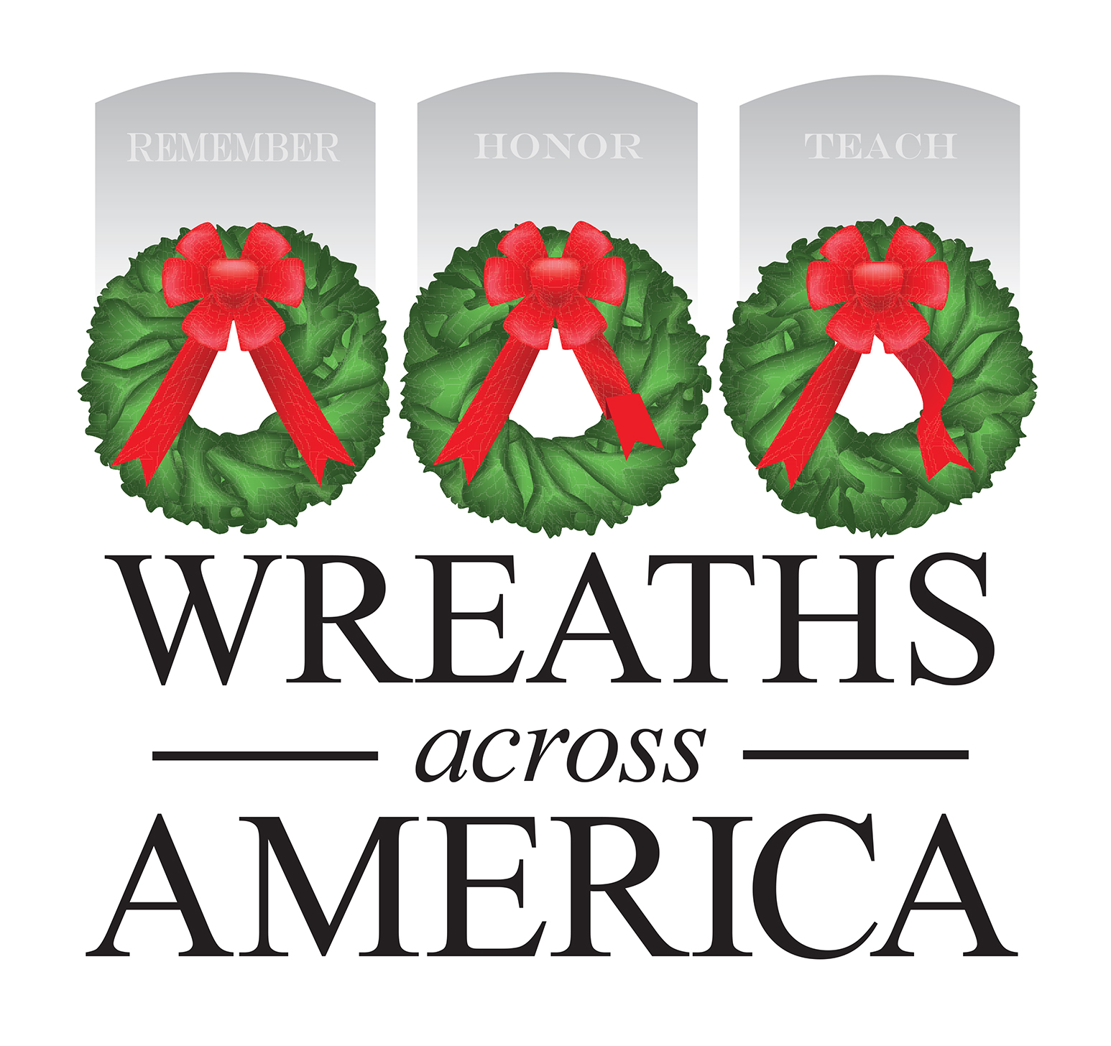
FOR IMMEDIATE RELEASE

[Sponsorship Group Name] Is Proud to Officially Announce Its Support for Wreaths Across America

[GROUP] will join volunteers and participating locations across the country to
Remember, Honor and Teach
Columbia Falls, MAINE, and [City, STATE] — [Date], 2022 — [Sponsorship Group] announced today that it has chosen to support Wreaths Across America participating location [Name of location(s) you support] as part of the national organization’s Group Sponsorship Program. This is the [FIRST, SECOND, etc.,] year that [Sponsorship Group] will participate in the national program whose mission is to Remember the fallen, Honor those who served, and Teach the next generation the value of freedom.

The goal for [Sponsorship Group] is to support efforts that help unify our community and celebrate our freedom by thanking the [insert total number] veterans laid to rest at [PARTICIPATING LOCATION(S) you are supporting] with the placement of a live, balsam veteran’s wreath this December.

Notes to consider including in your release:
- If you are a $5 back group, please include details about how you plan to use your $5 back to support local efforts.
- If you are returning group, include some details about your previous years’ effort and outcome.
- Share WHY you are participating in WAA as a Sponsorship Group

“We are forever grateful to all the volunteers and groups who dedicate their time and effort nationwide to fulfilling this yearlong mission,” said Karen Worcester, executive director, Wreaths Across America. “These individuals and their communities know the value of remembering the fallen, honoring those who currently serve and teaching the next generation about the sacrifices made for our freedom every day, and with their continued support, Wreaths Across America continues to grow.”

Those interested in volunteering for Wreaths Across America or sponsoring a wreath to support [Sponsorship Group] are invited to visit [insert direct link to your page, www.wreathsacrossamerica.org/YOURID] to learn more.

National Wreaths Across America Day will be held on Saturday, Dec. 17, 2022. WAA Day is a free, non-political, community event open to all people.
# # #

About Wreaths Across America
Wreaths Across America is a 501(c)(3) nonprofit organization founded to continue and expand the annual wreath-laying ceremony at Arlington National Cemetery begun by Maine businessman Morrill Worcester in 1992. The organization’s mission – Remember, Honor, Teach – is carried out in part each year by coordinating wreath-laying ceremonies in December at Arlington, as well as at thousands of veterans’ cemeteries and other locations in all 50 states and beyond. For more information, to sponsor wreaths or to sign up to volunteer, please visit www.WreathsAcrossAmerica.org.

Media contacts:
[NAME OF SPONSOR GROUP CONTACT]
[PHONE NUMBER]
[EMAIL]

National WAA HQ

Sean Sullivan
Wreaths Across America, Public Relations Manager
ssullivan@wreathsacrossamerica.org
207-230-4599

WREATHS ACROSS AMERICA MEDIA RESOURCES

WAA Media Resource Page
https://learn.wreathsacrossamerica.org/mediaresources

