FOR INTERNAL REVIEW ONLY
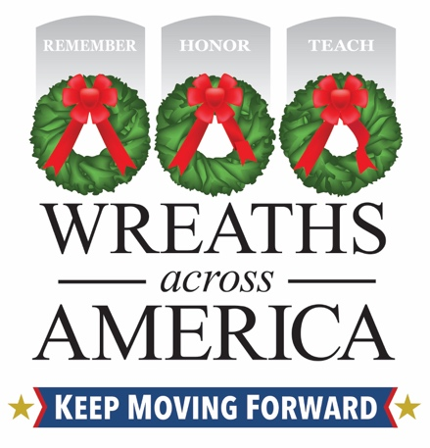
Join Wreaths Across America’s Annual Giving in July Celebration
Support [Name of Your Sponsorship Group] in your community, which is raising funds and sharing the mission to Remember, Honor and Teach.
COLUMBIA FALLS, Maine and (YOUR CITY, State) – DATE, 2025 – [Name of local group] is pleased to announce that it is participating in the national nonprofit Wreaths Across America’s (WAA) annual Giving in July campaign! For WAA, this annual celebration is dedicated to those local groups and individuals participating in the organization’s Sponsorship Group Program.
Locally, [name of your sponsorship group] counts itself as one sponsorship group supporting the mission to Remember, Honor and Teach. The goal for [Sponsorship Group] is to support efforts that help unify and celebrate our communities’ veterans and military families by thanking the [insert total number] servicemembers laid to rest at [participating location(s) your group supports] with the placement of a live, balsam veteran’s wreath this December.
Please visit [www.wreathsacrossamerica.org/YOURID] and sponsor a veteran’s wreath today. For every $17 wreath sponsored through the group, $5 will be applied forward to the sponsorship of an additional wreath!
Notes to consider including in your release:
- If you are returning group, include details about your previous years’ effort and outcome.
- Share WHY you are participating in WAA as a Sponsorship Group.

“We are forever grateful to all the volunteers and groups who dedicate their time, energy and resources nationwide to fulfilling this yearlong mission,” said Karen Worcester, executive director, Wreaths Across America. “Our Group Sponsorship Program is a year-round effort, but through “Giving in July,” we hope to remind people that veterans and our current military serve and protect us 365 days a year, and it is never too early to make a difference in your own community.”
More than 5,000 locations will participate in National Wreaths Across America Day this year on Saturday, December 13, 20245 – including at [name of locations your group supports]. This free event is open to all, and the organization encourages community members to participate by volunteering locally or sponsoring a wreath for an American hero.
Follow the hashtag #GivinginJuly to learn the impactful stories of volunteers and Sponsorship Groups doing good in their communities and benefitting from dollars raised through wreath sponsorships. Tune in to Wreaths Across America Radio to hear their stories, available on the iHeart Radio app, TuneIn, and the Audacy app, or at www.wreathsacrossamerica.org/radio.
About Wreaths Across America
Wreaths Across America is a 501(c)(3) nonprofit organization founded to continue and expand the annual wreath-laying ceremony at Arlington National Cemetery, which was begun by Maine businessman Morrill Worcester in 1992. The organization’s yearlong mission – Remember, Honor, Teach – is carried out in part each year by coordinating wreath-laying ceremonies in December at Arlington and at thousands of veterans’ cemeteries and other locations in all 50 states and beyond.
For more information or to sponsor a wreath, please visit www.wreathsacrossamerica.org.
WAA Press Contacts:
Rachael Wilson
rwilson@wreathsacrossamerica.org
(207) 230-4599

[LOCAL VOLUNTEER CONTACT INFO]
NOTES TO MEDIA AND PRESS MATERIALS: Please visit our Media Resources Page to download background, photos, logos, or other items to help you file your story.
Please get in touch with the local WAA Volunteer listed for interviews and more information about local efforts.

